**Neha Malhotra**  **R.L. Institute M: 9253556635**

**Max Time : 1 ½ hr** **Class = 12th Biology Test Max Marks : 40**

**Topic: Unit – 1 (Reproduction)**

**Section – A [ 1 X 15 = 15s ]**

1. Refer to the image of Papaver, identify X and Y.

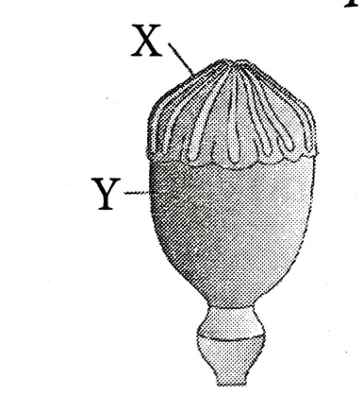

|  |  |
| --- | --- |
| a) X = syncarpous ovary ; Y = Stigma. | b) X = Stigma ; Y = Syncarpous ovary |
| c) X = Thalamus ; Y = Apocarpous ovary | d) X = Apocarpous ovary ; Y = Thalamus |

1. The given figure represents the locations in human female reproductive system that are affected by different birth controls methods. Identify them and select the correct option.

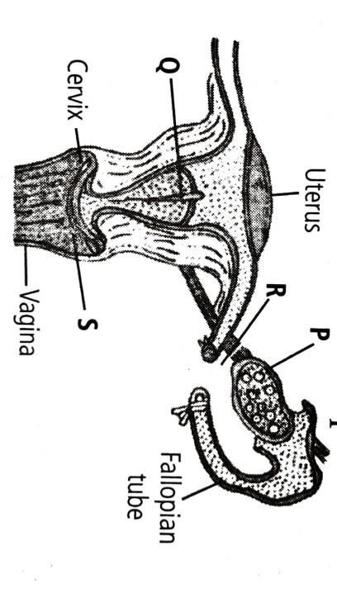

1. P = Copper T ; Q = Birth control pills ; R = Tubectomy ; S = Condom.
2. P = Birth control pills ; Q = Copper T ; R = Tubectomy ; S = Diaphragm.
3. P = Birth control pills ; Q = Diaphragm ; R = Ovariectomy ; S = Copper T.
4. P = Copper T ; Q = Birth control pills ; R = Ovariectomy ; S = Diaphragm.
5. Identify the diseases that can affect male and female genitals.

|  |  |  |  |
| --- | --- | --- | --- |
| a) Cholera | b) Pneumonia | c) Gonorrhoea | d) Amoebiasis |

1. Self pollination is fully ensured if :

|  |  |
| --- | --- |
| a) The flower is bisexual. | b) The style is longer than the filament. |
| c) The flower is cleistogamous. | d) The time of pistil and anther maturity is  different. |

1. 2n = 20 is in a primary spermatocyte , which is in metaphase of the first meiotic division. What shall be the total number of chromatids in each of the following secondary spermatocyte?

|  |  |  |  |
| --- | --- | --- | --- |
| a) 16 | b) 20 | c) 32 | d) 10 |

1. Match column-I with column-II and select the correct answer using the codes given below.

|  |  |  |
| --- | --- | --- |
| **Column – I** | **Column – II** | |
| 1. Parthenocarpy | 1. Seed formation without fertilization. | |
| 1. Polyembryony | 1. More than one embryo in same seed. | |
| 1. Apomixis | 1. Seedless fruit without fertilization. | |
| 1. False fruit | 1. Thalamus contributes to fruit formation. | |
| a) A – IV ; B – II ; C – III ; D – I | | b) A – III ; B – II ; C – I ; D – IV | |
| c) A – I ; B – IV ; C – III ; D – II | | d) A – II ; B – III ; C – I ; D – IV | |

1. A plant has 24 chromosomes in microspore mother cell. The number of chromosomes in its endosperm will be :

|  |  |  |  |
| --- | --- | --- | --- |
| a) 36 | b) 34 | c) 12 | d) 48 |

1. What is the correct sequence of sperm formation.
2. Spermatogonia , Spermatozoa , Spermatocytes , spermatids.
3. Spermatogonia , Spermatocytes , Spermatids , Spermatozoa.
4. Spermatids , Spermatocytes , Spermatogonia , Spermatozoa.
5. Spermatogonia , Spermatocytes , Spermatozoa , spermatids.
6. Which of the following approaches does not give the defined action of contraceptives.
7. Hormonal contraceptives = Prevent /retard the entry of sperms , prevent ovulation and fertilization.
8. Vasectomy = Prevent spermatogenesis.
9. Barrier methods = Prevent fertilization.
10. IUDs = Increase phagocytosis of sperm , suppress sperm motility and fertilizing capacity of sperms.
11. Which of the following is not found in a female gametophyte of an angiosperm?

|  |  |  |  |
| --- | --- | --- | --- |
| a) Germ pore | b) Synergids. | c) Filiform apparatus | d) central cell |

**Assertion-Reason Type Questions**

**DIRECTIONS :** In each of the following questions, a statement of Assertion (A) is given followed by a corresponding statement of Reason (R) just below it. Of the statements, mark the correct answer as:

1. If both assertion and reason are true, but reason is the true explanation of the assertion.
2. If both assertion and reason are true, but reason is not the true explanation of the assertion.
3. If assertion is true, but reason is false.
4. If both assertion and reason are false.
5. **Assertion:** The middle thick layer, myometrium is an important part of uterus.

**Reason:** Myometrium provides strong contractions during parturition.

1. **Assertion:** In plants, apomixis is a form of asexual reproduction that mimics sexual reproduction.

**Reason:** Apomixis involves the production of seeds without the fusion of gametes.

1. **Assertion:** The female genitalis includes mons pubis, labia majora and labia minora.

**Reason:** The glandular tissue of each breast is divided into 5 – 10 mammary lobes.

1. **Assertion:** Spermicidal creams and jellies are usually used along with intra-uterine devices to increase their contraceptive efficiency.

**Reason:** IUDs are effective and widely used contraceptives.

1. **Assertion:** After implantation, finger like projections appear on the trophoblast called chorionic villi.

**Reason:** Chorionic villi are surrounded by the uterine tissue and maternal blood.

**Section – B [ 2 X 5 = 10 ]**

1. Refer to the given figure showing parts of the human female reproductive system.

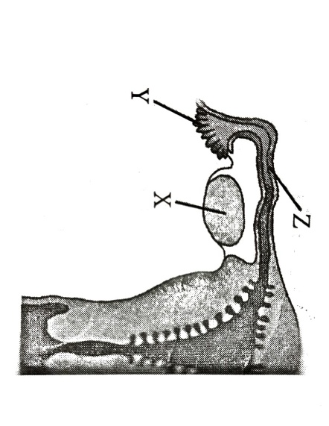

(a) Name the gamete cells that would be present in '(x)', if taken from a newborn baby.

(b) Name '(y)', and write its function.

(c) Name '(z)', and write the events that take place here.

1. (a) Differentiate between Geitonogamy and Xenogamy.

(b) Write the difference in the characteristics of the progeny produced as a result of the two processes.

1. (a) Study the following chart. Name the hormones involved at each stage. Explain their functions.

Hypothalamus → Pituitary → Testes → Sperm

(b) Explain with the help of schematic representation the process of formation of mature gamete in a human female.

1. (a) What are STIs? What are the consequences of delay in treatment of STIs?

(b) Name any 3 STDs and their causative organisms.

1. Where is sporopollenin present in plants? State its significance with reference to its chemical nature.

**Section – C [ 3 X 5 = 15 ]**

1. Study the transverse section of part of seminiferous tubules and answer the following parts:

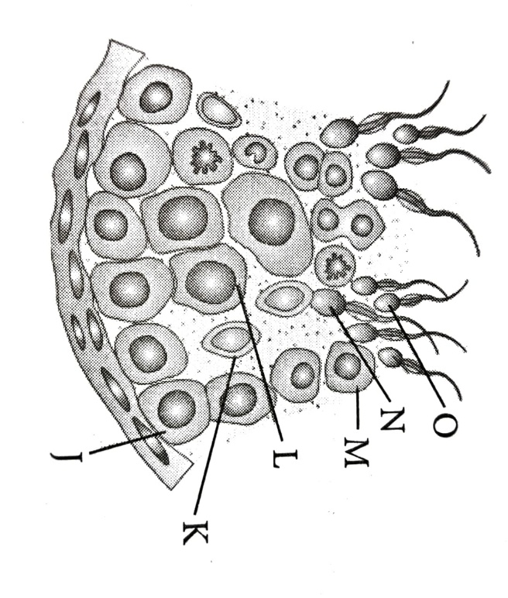

(a) Identify the cell that undergoes reduction division to form secondary spermatocytes.

(b) How many among the labelled parts have 46 chromosomes.

(c) State the role of 'K⁺' in this figure.

(d) Define spermiogenesis and spermiation.

1. (a) Explain how IVF as a technique helped childless couples in having children.

(b) Compare GIFT and ICSI in brief.

1. (a) Mention the agents which help in pollinating the given plants. Also, explain the adaptations in these plants to ensure pollination. (i) Vallisneria (ii) Water hyacinth (iii) Corn

(b) Why parturition is called neuro-endocrine mechanism?

1. If implementation of better techniques and new strategies are required to provide more efficient care and assistance to people, then why is there a statutory ban on amniocentesis? Write the use of this technique and give reason to justify the ban. Name any 4 disorders that can be detected by this technique
2. Explain the post-pollination events leading to seed formation in angiosperms.